Constellation of the Commons

Guide to Site Architecture and Maintainability Practices for the Non-Coder:

*Site Architecture Overview & How Everything Works*

**What is Omeka?**  **Omeka**  **content mgmt system**

We've built out this project using Omeka, which is an open source web publishing platform that is commonly used for digital scholarly projects and known for its rich metadata features. You can think of it as a content management system suited well for academic institutions. Generally speaking, Omeka is great for this project—storing records related to a set of social justice collectives and grouping them thematically—as it encourages record collecting and categorizing in an intuitive, not-too-techy interface called **Omeka Site Manager**. It should be noted, though, that a bit of customization is needed to express to a visitor (user) the notion of a thematic ‘constellation’ across these various collectives.

**General Overview of Site Structure**  **nav bar**  **page views**

On the site’s navigation bar, there are four different pages a visitor can go to:

*Homepage* | *About* | *Collectives* | *Protocol*

* *Homepage* houses the site’s main visualization of a spider web of connections btwn themes and collectives, or a “constellation of the commons” if you will.
* *About is a simple “about” page giving overview information on the project.*
* *Collectives* is the central page for browsing through the set of collectives either on the whole or by thematic tag.
* Protocol is a page detailing the permissible codes of use re: project data that lives on the site.

**Homepage & Constellation Visualization**  **dynamic viz**  **interactive tool**  **constellation effect**  **nodes & links**

The main visualization displayed on the homepage is intended to be an interactive tool for visitors, to help them explore the different thematic connections and mission overlaps across the collectives. Through engagement, the visitor can start to grasp the desired “constellation effect” of the project dataset and scope.

Here’s a high-level breakdown of the components in the viz:

* There are nodes, and there are links.
* Nodes are clickable objects in the viz:
  + Themes represented as color-coded circles.
  + Collectives represented as logo images.
* Links are the lines connecting various nodes together, representing a thematic relation.
* There is code that generates the viz by pulling data about themes and collectives from Omeka’s databases, and assigning this data to shapes and images. This code is executed whenever the homepage loads for a visitor! Since the code allows for real data to be incorporated, which can be updated live by site admins using Omeka Site Manager, the viz is considered to be **dynamic** vs. static.

**Incorporating Real Data from Omeka Site Manager**  **admin user** **organization item**  **logo images**  **exhibits**

How does the code for the homepage viz actually retrieve real data from record collections stored by the site? This is where site admins with access to the Omeka Site Manager (OSM) come in.

Here’s the high level:

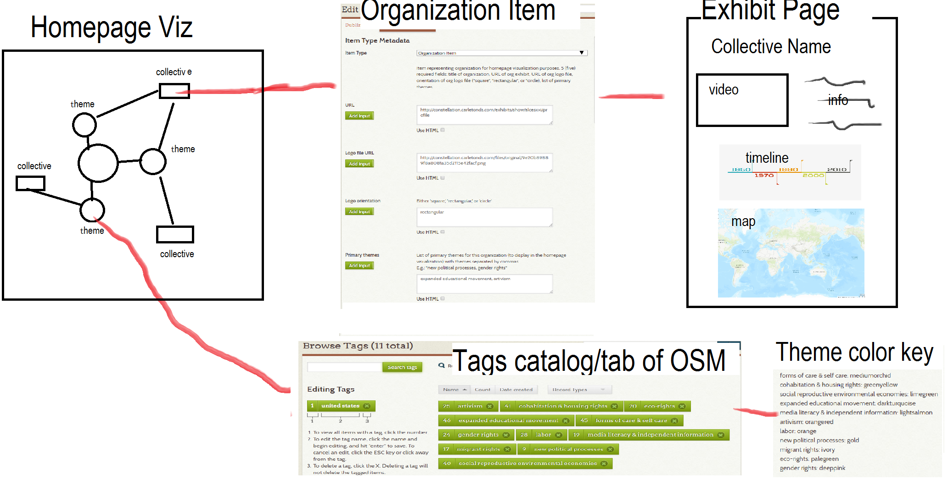

*Representing Collectives in OSM*

For every collective, there are 3 Omeka-standard components associated with it (denoted by typeface):

* Create Item of the type Organization Item – this stores data to be loaded specifically into the homepage viz
  + In Dublin Core tab, set Title field as the collective’s title
  + In Item Type Metadata tab, set Item Type to Organization Item and set the four required fields listed there as well, expanded upon below
    - URL – URL link to the collective’s Exhibit page
    - Logo file URL – link to the collective’s logo image (should be of Still Image item type)
    - Logo orientation – either ‘square’, ‘rectangular,’ or ‘circular’
    - Primary themes – List of 1-3 themes to connect to the collective **FOR THE VIZ ONLY** (These are the main themes associated with the collective, and will be the only themes to display as connected to the collective in the viz. We limit the number of primary themes to 3 as to relieve connection density and overall clutter in the viz.)
  + In the Tags tab, add **all** related tags for the collective—can be more than 3. **note: this is different from the primary themes field in the Type Metadata tab***). Adding tags for the collective allows Omeka to group the collectives by theme.
  + Lastly, on the block to the right, check off the Public box and for the Collection dropdown, select Organization Items. Then Save Changes.

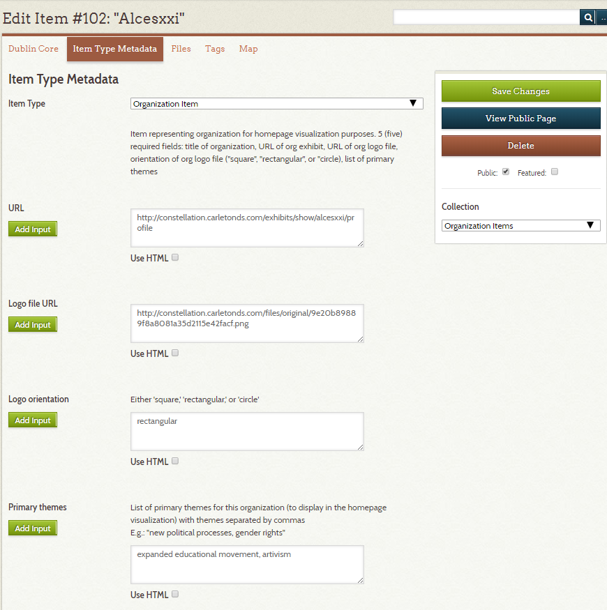

* Create Item of type Still Image – this is the collective’s logo image stored in distinct place in the Omeka database, to be associated with the collective’s Organization Item
  + In Dublin Core tab, set Title field as the collective’s title
  + In Item Type Metadata tab, set Item Type to Still Image and leave all remaining fields blank
  + In Files tab, upload a .png file of the collective’s logo image
  + Lastly, on the block to the right, check off the Public box and for the Collection dropdown, select organization logos. Then Save Changes.
  + **\*\*\*Note: To retrieve the logo image URL needed for the collective’s Organization Item, find the newly added img Item in the Item catalog, click on the image once, click on it again, and then click on it one more time. The logo should then render large and you can copy the URL here.**

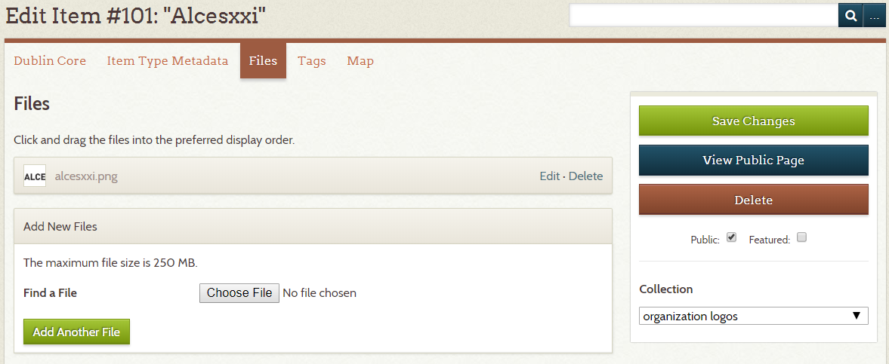

* Create Exhibit page – this a unique webpage on the site that stores the info for each collective (like profile for the collective)
  + In the Exhibit Metadata view, set the following metadata fields:
    - Title – collective’s title
    - Slug – collective’s title with dashes instead of whitespace (slug will be appended to the exhibit’s URL for search engine optimization)
    - Tags – add all tags associated with the collective
    - Theme – select Current Theme
    - Cover Image – select the logo image item you uploaded for this collective
  + The Pages block in the Exhibit Metadata view is where you will define the layout and content for the exhibit page.
    - The layout protocol is explained in detail in the next big header section on Exhibits.

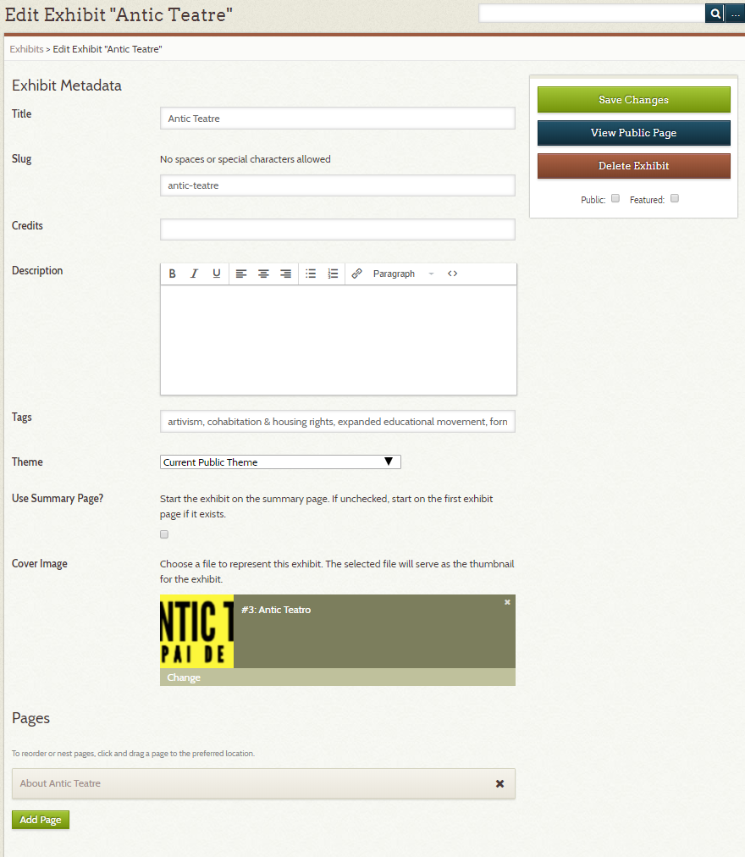

*-----  
Representing Themes in OSM*

Themes are tags in Omeka. Themes are defined in two places. The same list of themes with the same spellings and formatting should be used in both places.

* In the Tags catalog/tab of the OSM dashboard. Here you can browse the list of tags used on the site, which automatically updates every time you tag an Item or Exhibit. You can also see the number of Items and Exhibits associated with each tag in this tab.

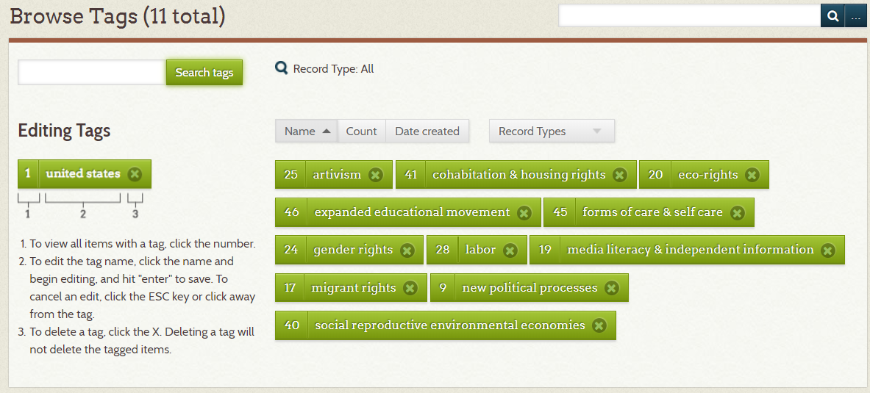

* In the Item titled “constellation of the commons” of type Viz Backend. You can access this item by typing “commons” into the search box of the Items catalog.
  + The Theme Color Key field houses the color key for all of the site’s themes in the following format: theme1: color1, theme2: color2, theme3: color3, etc.
  + If you need to change the color key, do so here.
* Whenever the names or formatting of a theme is changed, be sure to reflect this change in the Tags catalog AND the “constellation of the commons” Viz Backend Item.

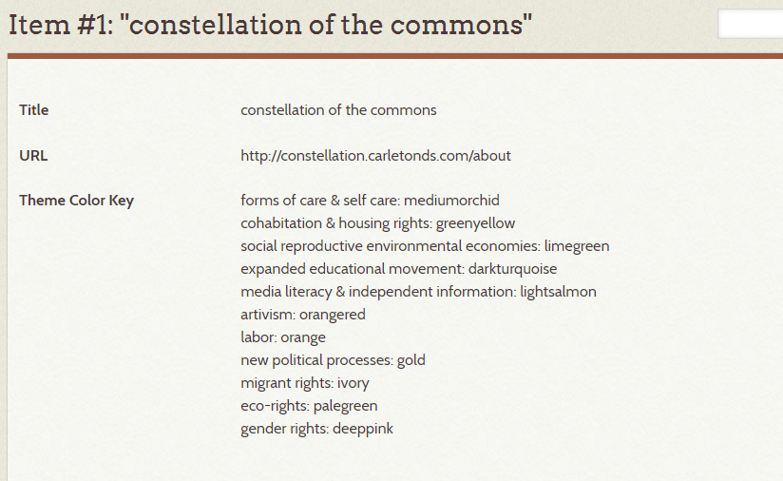

Laying Out Exhibits  **collective profiles** **video**  **timeline**  **map**

**\*\*\*\*MORE INFO ABOUT HOW TO ORGANIZE THE PIECES INTO A LAYOUT COMING SOON\*\*\*\***

Each collective, in addition to having an associated Organization Item, has an Exhibit page.

These are the necessary pieces of an Exhibit page:

* Interview video
* PDF transcription and translation
* Profile info (mission, date of establishment, website URL link, etc.)
* Tags displayed
* Timeline
* Map

*Browse Exhibits by Tag* functionality allows for visitor to view collectives that have a common theme (‘themes’ meaning all themes, not just the primary ones displayed in the viz) in the same space, further emphasizing the constellation effect!

